Solution 1

Piyush that sinx is the interchanging factor of the differential equation

∫Pdx=sinx
∫Pdx=log∣sinx∣

∫Pdx=∫cotxdx [∵∫cotxdx=log∣sinx∣+C]
P=cotx

solution 2
Focal chord is a chord that passes through the focus of the parabola
* In a right triangle having angleθθ,sinθ=sin⁡θ=perpendicularly divided by hypotenuse and cosecθ=1sinθcos⁡ecθ=1sin⁡θ.
*Length of focal chord of parabolay2=4axy2=4axmaking an angleθθ with the x-axis is given by 4acosec2θ4acos⁡ec2θ
Complete step-by-step answer:
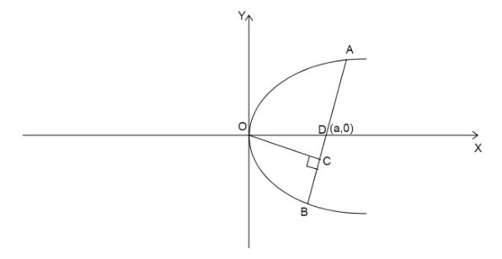
We are given a parabolay2=4axy2=4ax
Let us assume that the chord cuts the X-axis at point D(a,0)
Then according to the question we are given the shortest distance from center to the chord is b.
Length of the focal chord is c.
The distanceOD=aOD=a.
Let us assume the focal chord makes an angle x with the X-axis.
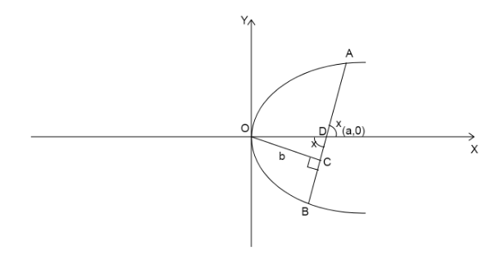
Since, we know vertically opposite angles are equal. Then,∠ODC=x∠ODC=x.
Since, the shortest distance is the perpendicular distance, then∠OCD=90∘∠OCD=90∘.
In right triangle OCD,
sinx=OCODsin⁡x=OCOD
Substitute the value of OD as a and OC as b
⇒sinx=ba⇒sin⁡x=ba
Since we knowcosecx=1sinxcos⁡ecx=1sin⁡x
⇒cosecx=1ba⇒cos⁡ecx=1ba
⇒cosecx=ab⇒cos⁡ecx=ab… (1)
We know focal chord of a parabolay2=4axy2=4axmaking an angleθθwith the X-axis is of length4acosec2θ4acos⁡ec2θ
Therefore, we can write c=4acosec2xc=4acos⁡ec2x
Substitute the value of cosecxcos⁡ecx from equation (1)
⇒c=4a(ab)2⇒c=4a(ab)2
Open the value on the bracket .
⇒c=4a3b2⇒c=4a3b2
Cross multiply the value in denominator of RHS to LHS
⇒b2c=4a3
solution 3

The number of letters in the word ‘HARSHITA’ are 8, where A and H come twice.
The number of permutations to arrangennletters is given byn!n!, where no letter is repeated.
The number of permutations to arrangennletters is given byn!r1!r2!…rn!n!r1!r2!…rn!, where a letter appearsr1r1times, another letter repeatsr2r2, and so on.
We can find the answer using four cases.
Case 1: The first space has an A, and the eighth space has a H.
Since 1 A and 1 H are fixed at the two spaces, we have 6 remaining letters to be placed in 6 spaces.
The 6 remaining letters are R, S, H, I, T, A.
We observe that no letter is being repeated.
Therefore, the number of words that start with an A and ends with a H, is

6!=6×5×4×3×2×1=7206!=6×5×4×3×2×1=720
Case 2: The first space has an I, and the eighth space has a H.
Since 1 I and 1 H are fixed at the two spaces, we have 6 remaining letters to be placed in 6 spaces.
The 6 remaining letters are R, S, H, A, T, A.
We observe that the letter A is being repeated twice.
Therefore, the number of words that start with an I and ends with a H, is
6!2!=6×5×4×3×2×12×1=3606!2!=6×5×4×3×2×12×1=360
Case 3: The first space has an A, and the eighth space has a consonant other than H.
The letter A is fixed at the first place.
The eighth space has a consonant other than H, that is R, S, or T.
Therefore, there are 3 ways to fill the eighth space.
Now, we observe that the 6 remaining letters will have the letter H twice.
Therefore, the number of words that start with an A and ends with a consonant other than H, is
3×6!2!=3×6×5×4×3×2×12×1=10803×6!2!=3×6×5×4×3×2×12×1=1080
Case 4: The first space has an I, and the eighth space has a consonant other than H.
The letter I is fixed in the first place.
The eighth space has a consonant other than H, that is R, S, or T.
Therefore, there are 3 ways to fill the eighth space.
Now, we observe that the 6 remaining letters will have the letters A and H twice.
Therefore, the number of words that start with an I and ends with a consonant other than H, is
3×6!2!2!=3×6×5×4×3×2×12×1×2×1=5403×6!2!2!

=3×6×5×4×3×2×12×1×2×1=540
Now, we will add the results of the four cases to get the number of words that start with a vowel and end with a consonant.
Number of words=720+360+1080+540=2700=720+360+1080+540=2700
Therefore, the number of words which begin with a vowel and end with a consonant by permuting the letters of the word ‘HARSHITA’ is 2700.
Note:
We can also solve this problem using the subtraction rule. We can find that the number of words that start with a vowel are
7!2!+7!2!2!

=7×6×5×4×3×2×12×1+7×6×5×4×3×2×12×1×2×1=2520+1260=37807!2!+7!2!2!=7×6×5×4×3×2×12×1+7×6×5×4×3×2×12×1×2×1=2520+1260=3780
Similarly, we can find that the number of words that start with a vowel and end with a vowel are
6!2!+6!=6×5×4×3×2×12×1+6×5×4×3×2×1=360+720=10806!2!+6!=6×5×4×3×2×12×1+6×5×4×3×2×1=360+720=1080
Therefore, using the subtraction rule, we get the number of words which begin with a vowel and ends with a consonant as3780−1080=2700

